PEOPLES KENNYWOOD 2026 PICNIC - FAQ & HOW-TO GUIDE
FAQ:
- Can I order complimentary shirts on this site?
  - No, complimentary shirts are only available through the survey sent out by Peoples
- What is the URL for the website?
  - https://peoplespicnicstore.com/
- How long do I have to place my order?
  - The store is open through July 17th. You must submit your order during this time.
- Do I need to enter my credit card information?
  - Yes, this site is only for additional shirts that individuals wish to purchase with their personal credit card. Complimentary shirts must be selected via the survey sent out by Peoples.
- Do I need to register and create an account before ordering?
  - YES, all participants must create an account to allow for proper tracking of their order details. After registering, you can then place your order.
- What address should I enter on the Guest Detail page when registering?
  - Please enter the address associated with your credit card. This information will ONLY be used if you end up purchasing additional shirts.
- I need additional park tickets for Kennywood, am I able to get more?
  - YES, Peoples is providing up to 4 complimentary tickets to current employees and up to 2 complimentary tickets to former employees. Additional tickets can be purchased at www.kennywood.com using your discount code provided by Peoples Gas
- Can I have my order shipped directly to my house?
  - NO, all orders will be shipped to a Peoples office. Please select the closest one to you via the drop down at checkout.
- When will I receive my Kennywood order?
  - Orders will be delivered to the selected office for distribution the week of 8-24 to 9/4
- What is the date of the event at Kennywood?
  - September 12, 2026

HOW-TO Guide:

- Please register by clicking on “My Account” or “Shopping Cart” once on the website
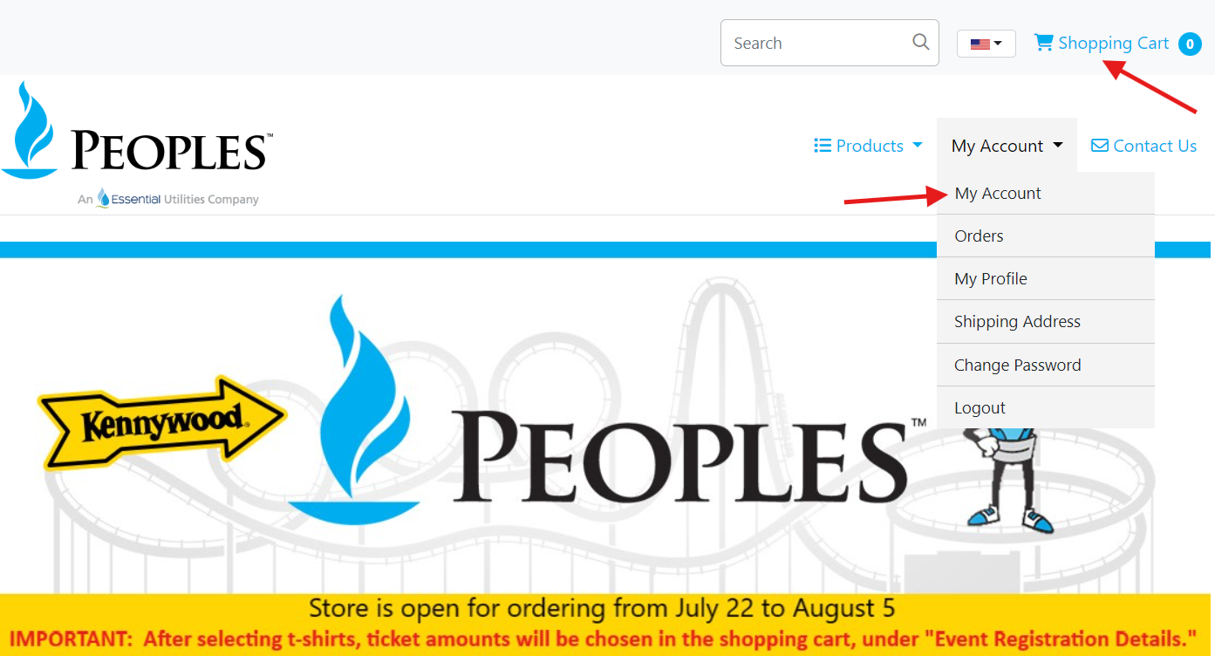

- Sign up by entering all required information and then clicking submit:
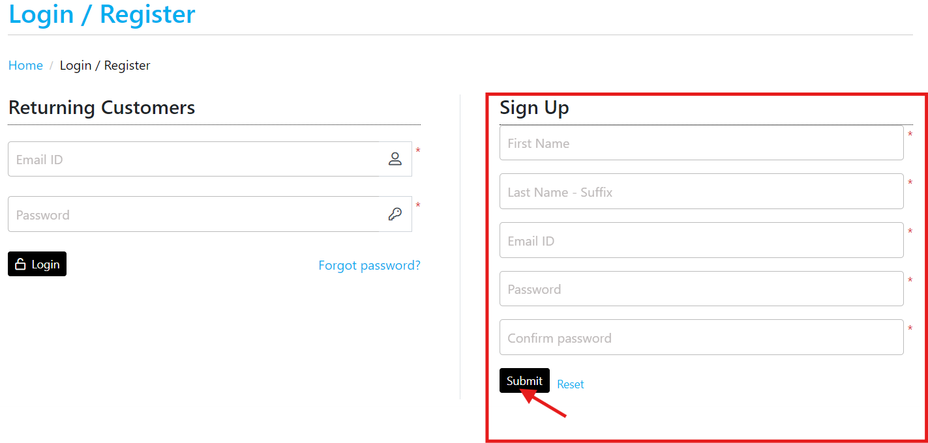

- Complete the Guest Detail page. Billing information should match the address associated with your credit card. 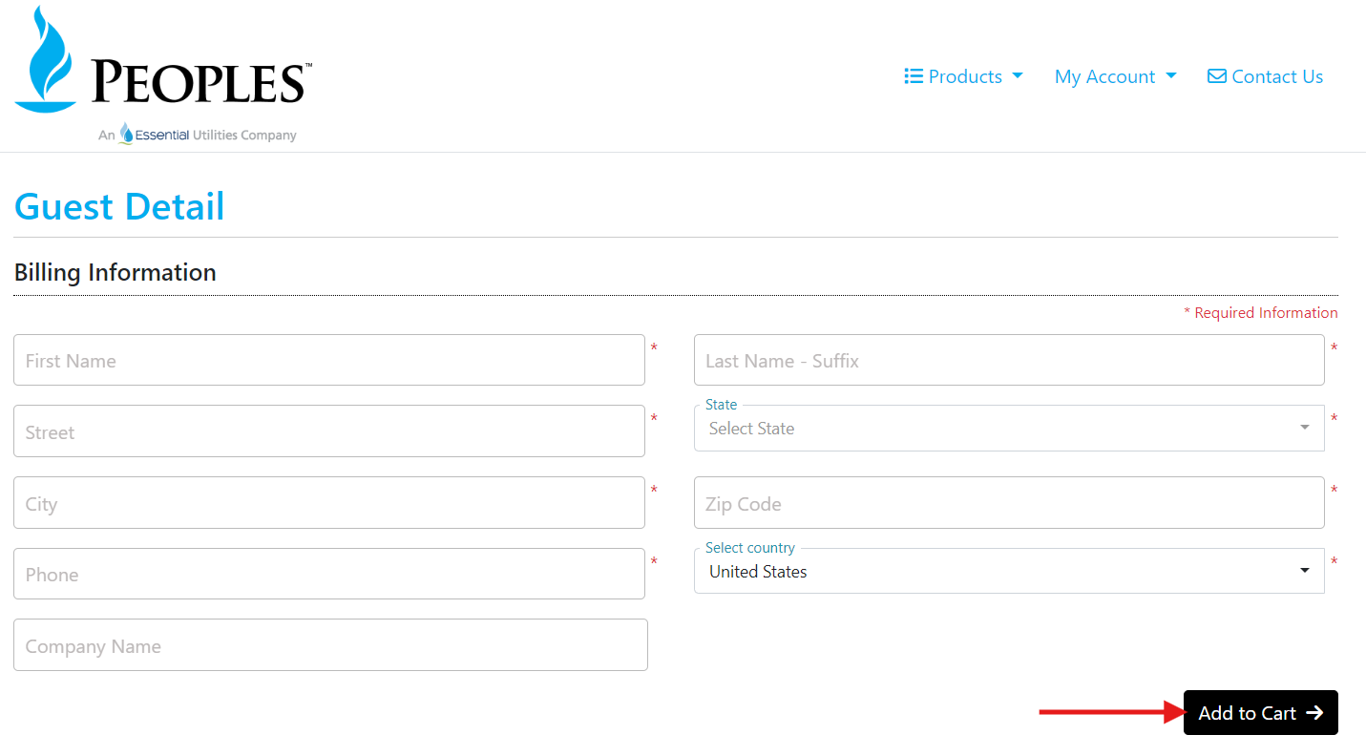

- Select the sizes you need between the adult or youth shirts. Shirts will feature a screen-printed design based on the Exterminator ride:
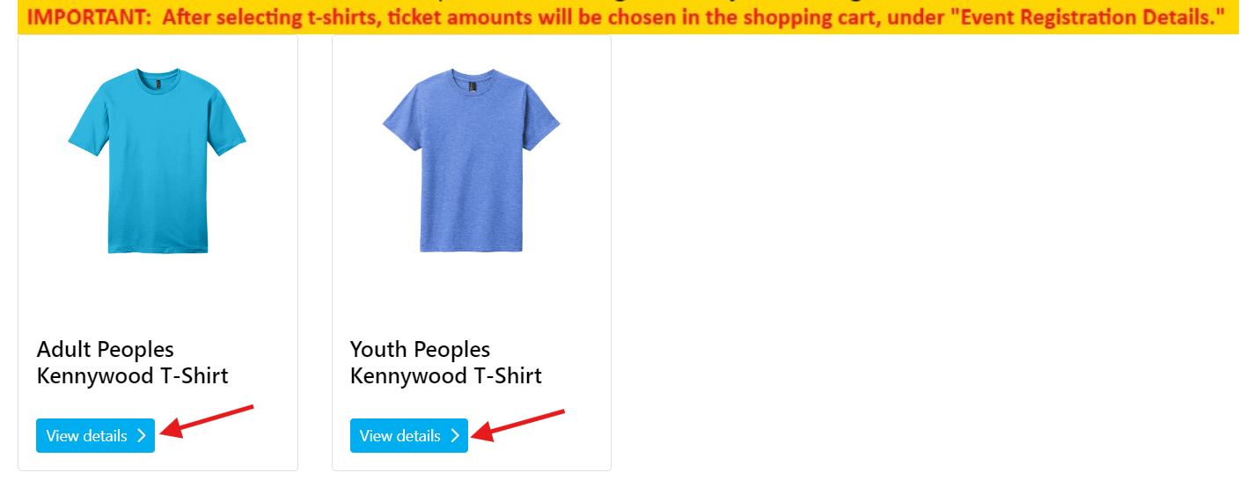

- When ready to checkout, select your “Shopping Cart”:
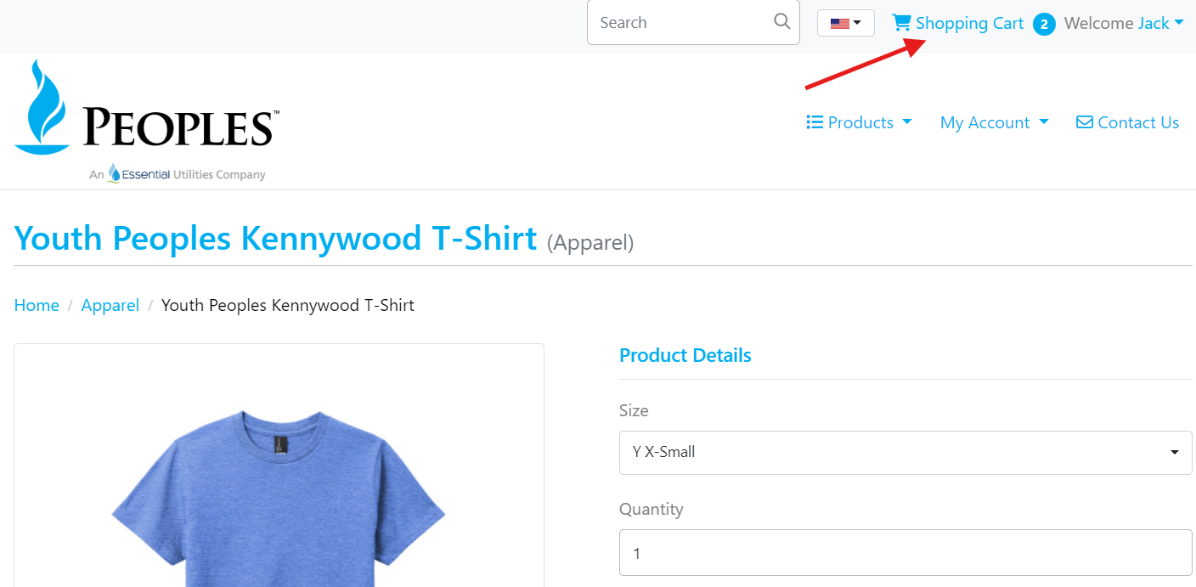

- Select your office (or the closest one to you if a retiree) and confirm billing address is correct. Billing address should match the address on file with credit card and will be used if ordering more than four T-shirts:
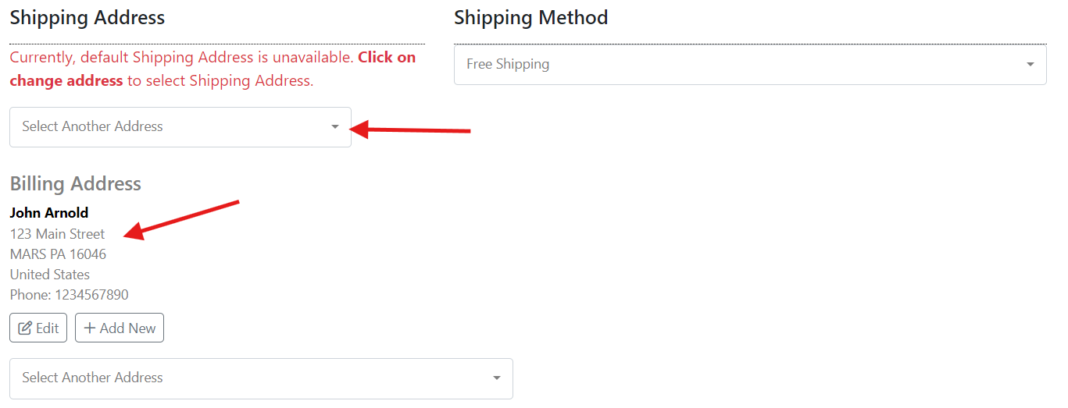

- You must enter your credit card information. This site is ONLY for ordering additional shirts with your personal credit card. Peoples is providing up to 4 complimentary T-shirts which must be selected within the survey.
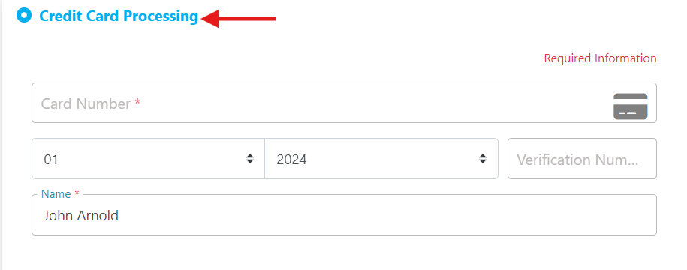

- Click “Order Complete” once finished. You will receive a confirmation message and email once done. If you do not receive a confirmation email, then you did not successfully complete the required checkout steps.

